#CSC 521 Assignment 3 by Zhenyang Lu

Consider a small shipment company that every day ships N packages where N is random variable following the Poisson distribution with average of 100 packages per day. Each package is automatically insured for a random value following the Pareto distribution with an alpha of 3.0 and xm of $200. Each package has a 2% probability of being lost. How much capital should the shipping company set aside at the beginning of every year to cover the costs of lost packages, so that the probability of default is less than 3%?

0. Analysis of the solution

STEP 1: To simulate how many parcels shipped by day, you should write a code generating a Poisson random number using code:

*def poisson(lamb): #define a poisson PRNG*

*u = random.random()*

*prob= exp(-lamb)*

*k=0*

*while 1:*

*if u <=prob:return k*

*else:u=u-prob*

*prob = float(lamb)/(k+1)*prob*

*k+=1*

STEP 2: To simulate how much each parcel is insured, you should define a Pareto random number generator:

*def pareto(xm,pareto_a): #define a pareto PRNG*

*u = random.random()*

*return xm*(1-u)**(-1.0/pareto_a)*

STEP 3: Since 2% is every parcel likely to be lost, you generate a random number between 0 and 1, if it is below 0.02, then it indicates that the parcel has been lost. Then you redeem the parcel by generate a Pareto random number as the compensation (lost to the shipping firm) using the code in STEP 2. This is the process for the simulation of one parcel. Then you using Poisson random number generator to get a random number with a parameter of 100 to assume how many parcels you ship everyday. Finally, extend your shipping business from one day to a year (250 days).

STEP 4: You sum up the total redeem for the lost parcels, then compute how much you should deposit every year in cash you are default with a possibility of higher than 3% by simulating many times of yearly losses and get the 3% percentile of them. Combined with STEP 3, STEP 4 is defined as simulate_once( ) by the following code:

*import random*

*from math import \**

*working_days = 250*

*amount_list= []*

*amount_list2 = []*

*def pareto(xm,pareto_a): #define a pareto PRNG*

*def poisson(lamb): #define a poisson PRNG*

*package_loss = [] # define a list that contains pareto random numbers,*

*for i in range(10000): # which is used to resample the possible losses for lost parcel*

*package_loss.append(pareto(200, 3.0))*

*package_shipped_perday = [] # define a list that contains poisson random numbers,*

*for i in range(10000): # which is used to resample the number of parcels shipped daily*

*package_shipped_perday.append(poisson(100))*

*def simulate_once():*

*sum = 0.0*

*amount = 0.0*

*amount_list = []*

*for i in range(0,working_days):*

*amount = .0*

*for p in range(0,package_shipped_perday[random.randint(0,len(package_shipped_perday)-1)]):*

*if 0.02>random.random() :*

*amount = amount + package_loss[random.randint(0, len(package_loss)-1)]*

*amount_list.append(amount)*

*amount_list.sort()*

*for i in range(int(working_days)):*

*sum = sum + amount_list[i]*

*return sum*

STEP 5: simulate the above code for N times and get the 3 % percentile as your final result. Code is like:

*def simulate_many(n):*

*fp = open('simulate_many.txt','w')*

*amount = 0.0*

*for i in range(n):*

*amount_list2.append(simulate_once())*

*for i in range(n):*

*print >>fp,amount_list2[i]*

*fp.close()*

*print amount_list2[int(n*0.97)] # return the 97% percentile*

1. Approximation of the result

E[Parcels shipped per day] = 100 dollars

E[insurance per parcel] = alpha*Xm/(alpha-1) = 3*200/2 = 300 dollars

Since there is 2% likely losing the parcel,

E[redeem per day] = 100*300*2% = 600

E[redeem per year] = 600 * 250 = 150000

2. Graphics and python result

Simulate_once():

Simulate_many(500):

And

For the Python result:

C:\Users\felix\Desktop\csc521\assingment3\2.jpg

3. Full python code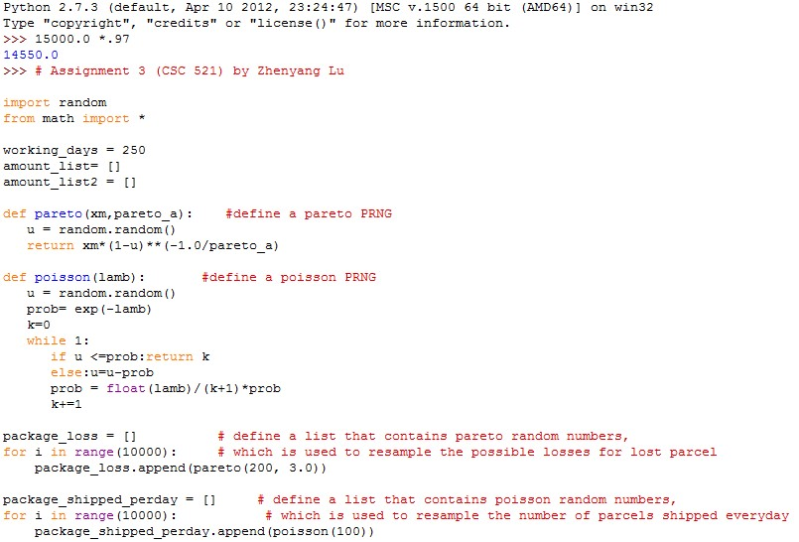

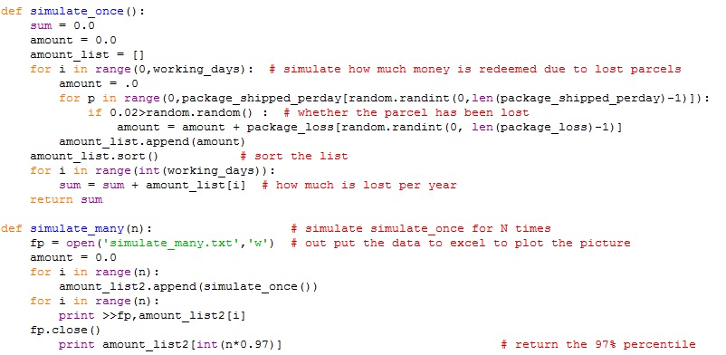

*Plot is done by Excel